**Lack of Association Between Genetic Variants at ACE2 and TMPRSS2 Genes Involved in SARS-CoV-2 Infection and Human Quantitative Phenotypes**

<http://doi.org/10.3389/fgene.2020.00613>

**Notes:**

Genetic variation in TMPRSS22 and ACE2 may modulate a person’s genetic predisposition to infection and virus clearance. A total of 178 quantitative phenotypes including cytokines and cardio-metabolic bio markers and 58 medication types were investigated among N = 36,339 volunteers in relation to 1273 genetic variants located on or near ACE2 and TMPRSS2. Though none reached a threshold for significance a few observations were made.

1st – SNPs near TMPRSS2 genes were associated with thrombocytes count

2nd – SNPs near ACE2 gene were associated with the use of ARBs combination therapies.

3rd – stronger associations were made in female volunteers and volunteers who used non-steroid anti-inflammatory and anti-rheumatic products.

Authors suggest that variants may play a role in disease such as thrombocytopenia, hypertension, and chronic inflammation (seen in the clinical presentation of COVID-19 subjects).

Quantitative Phenotypes

* None were found to be significant at the genome-wide level
* Most associations were found within quantitative traits at the ACE2 locus were triglycerides (rs5980163) and eosinophil counts (rs17264937)
* Strongest associations at TMPRSS2 were plasma levels of CHIT1 (rs150965978) and thrombocytes (rs28401567).
* Only association at res5980163 with triglycerides at ACE2 showed differential effect between male and females.

Medication use

* Strongest association at ACE2 locus were observed for group of drugs that contain NSAIDS and ARBs in combination with anti hypertensive drugs.
* Individuals carrying at least 1 T allele at rs4646156 polymorphism were likely to take this combined therapy compared to individuals
* Association with ARB combination therapies could indicate that individuals in whom it is difficult to manage hypertension may be genetically pre-disposed to this state of rs4646156
* Strongest association at TMPRSS2 locus were observed for the group of drugs containing antimycotics prescription and for corticosteroids

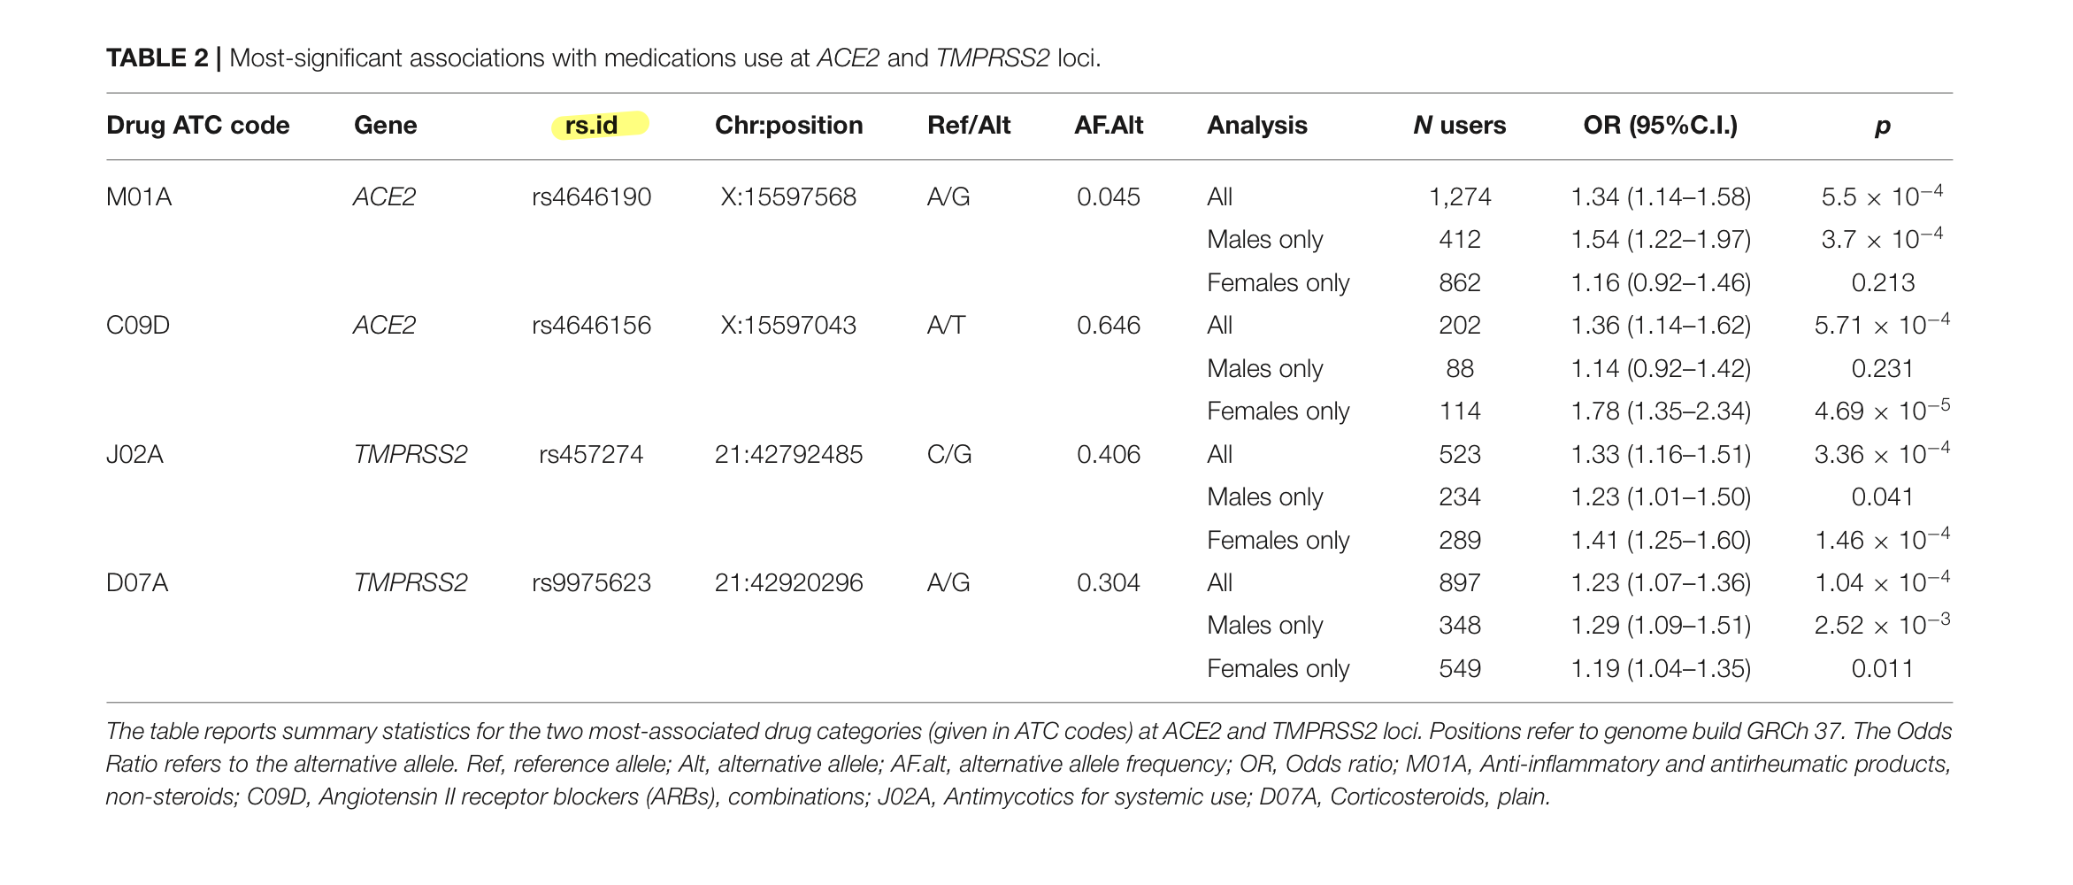

**First comprehensive computational analysis of functional consequences of TMPRSS2 SNPs in susceptibility to SARS-CoV-2 among different populations**

<https://doi.org/10.1080/07391102.2020.1767690>

**Notes:**

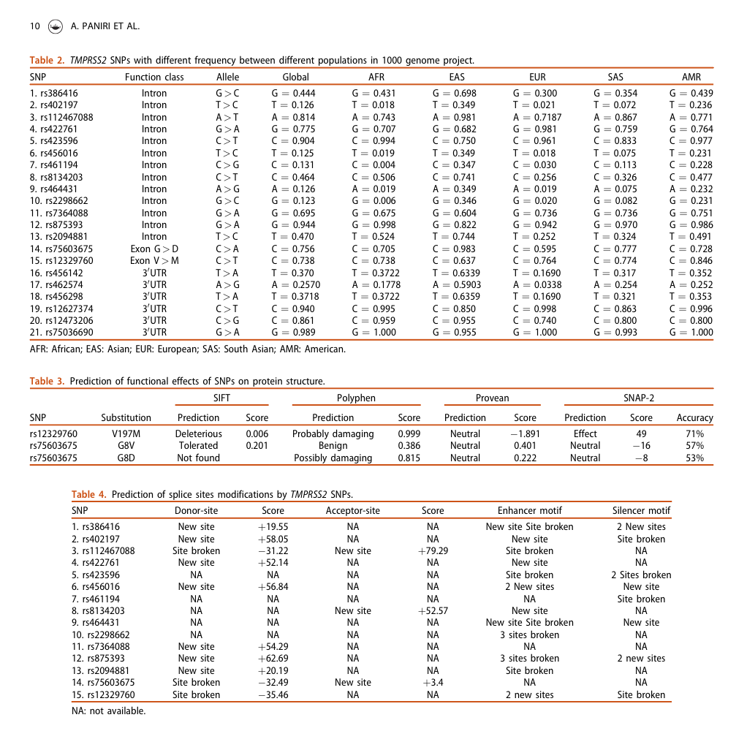Study aims to investigate the impact of SNPs on TMPRSS2 function and structure in silico. Only 21 SNPs affected the function and structure of TMPRSS2 by influencing the protein folding, PTM, splicing, and miRNA function, particularly rs12329760, which may create a de novo pocket protein. rs875393 can create a donor site, silencer and broken enhancer motifs. rs12627374 affects a wide spectrum of miRNAs profile. This study highlighted the role of TMPRSS2 SNPs and epigenetic mechanisms especially non-coding RNAs in appearance of different susceptibility to SARS-CoV-2 among different populations. Also, this study could pave the way to potential therapeutic implication of TMPRSS2 in designing antiviral drugs.

* TMPRSS2 is located on 21q22.3 and contains 15 exons. The protease is highly expressed in prostate, colon-transverse, stomach, and lung, mostly comprised of Gly, Ser, Val, Pro, and Leu amino acids, and is cleaved by trypsin into 27 fragments. TMPRSS2 expression is higher in prostate adenocarcinoma (PRAD), with survival rate of patients decreased with age.
* Out of 493 SNPs, frequency of 92 SNPs were significantly different between Asian population and other populations. Out of the 92, 21 influenced the function of the protein. Out of 21 SNPs, 9 (rs423596, rs8134203, rs464431, rs2298662, rs2094881, rs75603675, rs456142, rs462574 and rs456298) showed a significant difference in frequency between Asian population and other populations. Also, the frequency of 2 SNPs (rs402197 and rs456016) were similar between Asian and American populations whereas they were different in comparison with other populations. One SNP (rs461194) revealed a considerable different frequency between African population and others. Additionally, 8 SNPs (rs422761, rs8134203, rs2094881, rs75603675, rs456142, rs462574, rs456298 and rs12473206) revealed a notable different frequency between European and others. Astonishingly, comparison of European and African populations demonstrated that 5 SNPs (rs402197, rs456016, rs461194, rs464431 and rs2298662) showed almost equal frequencies.

**ACE2 and TMPRSS2 Variants and Expression as candidates to sex and country differences in COVID-19 severity in Italy (non-peer-reviewed)**

<https://doi.org/10.1101/2020.03.30.20047878>

**Notes:**

Purpose of the study was to investigate the possible genetic components of the peculiar severity of COVID-19 among Italians, by looking at the expression levels and variants in ACE2 and TMPRSS2 genes. Author indicates no significant evidence that ACE2 is associated with disease severity/sex bias in the Italian population. TMPRSS2 levels and genetic variants prove to be possible candidates for disease modulators, with similarities in the ACE2 transcript in both men and women. With available data, it seems unlikely that sex-differences in ACE2 levels can explain sex differences in disease severity.